**Assignment**

Please spend 2 days (48 hours) to complete the application.

* The spec below may not be complete/clear enough as is the case with real business scene. You are expected to create solution with the given spec.
* You can add any other functions/forms/DataGrid etc which you believe it will be necessary for this entry form.
* For submission, please only share uncompiled files.
* Please inform your agent in advance in case of any delay in submission.

**Specification – User Profile Entry Form**

Please create a User Profile Entry Form by using Visual Studio C#.NET as Windows application. Candidate can choose to complete the task in either WinForms, WPF (JRIE have no preference between WinForms and WPF), or as Web application (only when JRIE instructed to complete as web application). The screen image is as follows.

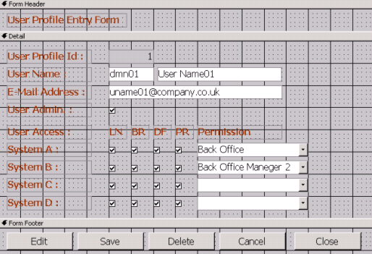

System specification from a project manager is …

1. “User Profile Id” is allocated automatically by Database
2. “User Name” is consisted from Domain and Full name.
3. “User Admin” check box shows the permission to edit this User Profile information.
4. 10 systems (System A-L) are registered.
5. 4 branches (LN, BR, DF and PR) are registered.
6. Permission is defined by each system.
7. When data (record) is deleted by users, please set “-1” to the status field of each table. (Not physically deleted.)
8. Other instructions are:

|  |  |
| --- | --- |
| Do… | Don’t… |
| - Use .NET Framework 4.0 or lower version. | -Don’t use any third-party components/dlls.  -Don’t use .NET Entity Framework.  -Don’t use SQL Server stored procedures/triggers. |

**Guidance on Handing Assignment**

Please note JRIE and SMBC BI has strict security policy/operation for file submission. Any failure in following guidance will result a delivery failure, thus carefully review each process when you hand your work.

1. **Review files to submit**

|  |  |
| --- | --- |
| Do… | Don’t… |
| -Clean the solution.  -Search in the whole projects or folders by *.exe, *.dll, *.bat to make sure these files are not included.  -Check again if any of exe, dll, bat files are not included in case you have downloaded a package.  -Remove all the files not related to the assignment. | -Don’t include any EXE, DLL and BAT file. |

1. **Compress the folder**

|  |  |
| --- | --- |
| Do… | Don’t… |
| -Compress the folder in ZIP format. | -Don’t set a password.  -Don’t compress in the format other than ZIP (such as TAR, RAR, 7z, etc.. ). |

1. **Submit the ZIP file**

|  |  |
| --- | --- |
| Do… | Don’t… |
| -Attach the ZIP file to an email  -Include your agent and [JRIEDevRecruitment@gb.smbcgroup.com](mailto:JRIEDevRecruitment@gb.smbcgroup.com) to receiver. | -Don’t use file sharing service (We never allow to use any of the services such as Google Drive, Dropbox, One Drive, etc…)  -Don’t hand the file with USB stick in person. |

1. **Check error message after submission**

|  |  |
| --- | --- |
| Do… | Don’t… |
| -Check your inbox and spam folder if you receive an error message after few minutes |  |